
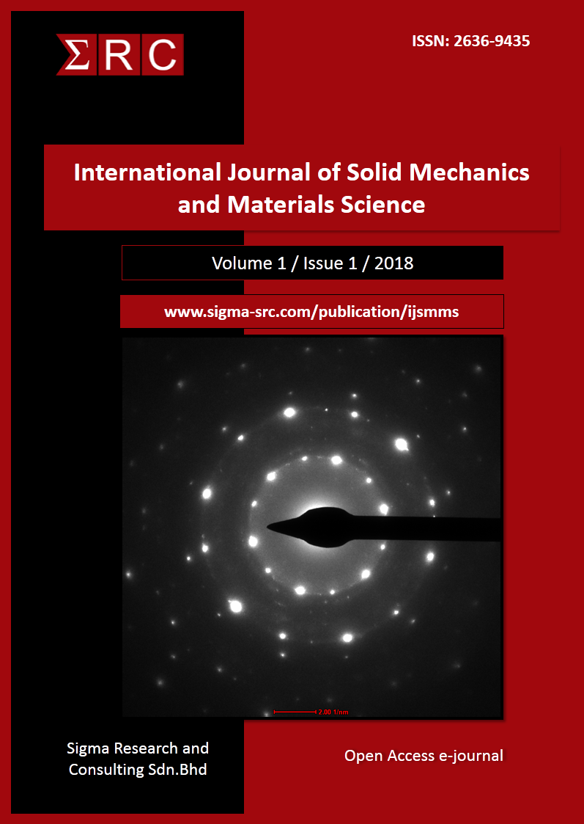
International Journal of Solid Mechanics and Materials Science, 1 (x) (2019) xxx-xxx

International Journal of Solid Mechanics and Materials Science

Website: http://www.sigma-src.com/publication/ijsmms

Title of the article
First Author¹*, Second Author², Third Author³
¹Affiliation of the first author
²Affiliation of the second author
³Affiliation of the third author
*Corresponding author E-mail:

Abstract

The manuscript should contain an abstract. The abstract should be in one paragraph and should not exceed 200 words. The abstract should state the purpose, approach, results and conclusions of the work. The author should assume that the reader has some knowledge of the subject but has not read the paper. Thus, the abstract should be intelligible and complete in it-self (no numerical references); it should not cite figures, tables, or sections of the paper. The abstract should be written using third person instead of first person.

Keywords: Use about five key words or phrases in alphabetical order, Separated by Semicolon.

- Introduction
This document can be used as a template for Microsoft Word versions 6.0 or later. Do not submit papers written with other editors than MS Word, it will not be accepted for review. Save the files to be compatible with many versions of MSWord (avoid other document extension than *.doc, *.docx or *.rtf). Do not submit papers without performing a carefully spellcheck and English language grammar check. The style from these instructions will adjust your fonts and line spacing. Please do not change the font sizes or line spacing to squeeze more text into a limited number of pages.
- Page layout
An easy way to comply with the paper formatting requirements is to use this document as a template and simply type your text into it.
Your paper must use a page size corresponding to A4 which is 21cm wide and 29.7cm long. The margins must be set as follows:
Top = 1.5cm
Bottom = 1.5cm
Left =2cm
Right=1.5cm
Your paper must be in two column format with a space of 0.5cm between columns.

2.1. The paper should have the following structure
1. Title of the paper
2. Authors and affiliations
3. Abstract
4. Keywords
5. Introduction
6. Main body
7. Conclusions
8. References
- Page style
All paragraphs must be justified alignment. With justified alignment, both sides of the paragraph are straight.

3.1. Text font of entire document
The entire document should be in Times New Roman. The font sizes to be used are specified in Table 1.

3.2. Title and author details
All title and author details must be in single-column format and must be centred.
Only the first word in a title must be capital and other word should be in small case. Author details must not show any professional title (e.g. Managing Director), any academic title (e.g. Dr.) or any membership of any professional organization (e.g. Senior Member IEEE).
To avoid confusion, the family name must be written as the last part of each author name (e.g. John A.K. Smith).
Each affiliation must include, at the very least, the name of the company and the name of the country where the author is based (e.g. Causal Productions Pty Ltd, Australia). Email address is compulsory for the corresponding author.

3.3. Section headings
No more than 3 levels of headings should be used. Other headings must be in 9pt font. Only the first word in a heading must be capitalized and other word should be in small case.
Level-1 Heading: A level-1 heading must be in left-justified and numbered with an Arabic numeral. The two level-1 headings which must not be numbered are “Acknowledgment” and “References”.
Level-2 Heading: A level-2 heading must be left-justified and numbered with an Arabic numeral followed by a period.
Level-3 Heading: A level-3 heading must be numbered with an Arabic numeral.
The section should be formatted as left, bold, Times New Roman, and 12pt font size. For subsection (left, bold, Times New Roman, and 10pt), the initial letter of first word should be capitalized and also similarly for other sub-subsections (left, bold, Times New Roman, and 9pt).

Table 1: Font Specifications for A4 Papers

Font Size | Appearance (in Time New Roman)
Font Size | Regular | Bold
8 | table caption, centered  figure caption, centered  reference item
9 | Author’s affiliation, centered  Paragraph  abstract body | level-3 heading, left-justified
10 |  | author name, centered  level-2 heading, left-justified
12 |  | level-1 heading, left-justified  reference heading  acknowledgement heading
18 |  | Paper title, centered

3.4. Figures and tables
Graphs and other numbered figures should appear throughout the text as close to their mention as possible. Figures shouldn’t infringe upon the page borders.
Figures and tables must be centered in the column. Large figures and table can be in one column in order to see them more clearly and avoid placing them in the middle of columns. Any table or figure that takes up more than 1 column width must be positioned either at the top or at the bottom of the page
Photos must be crystal clear with such resolution to allow fine details visibility. The elements from any photo must be explained using numbers, letters, etc. The text within a figure or photo must have the same style, shape and height as the caption has.
Any table, figure or picture must have a caption (Fig.1, Table1, etc.) followed by a proper description. All similar graphics must be generated using the same software product (Excel, Origin, Mathematica, etc.). Importing graphics into the article as images (JPG, BMP, PNG, etc.) should be avoided. All similar electronic schematics, charts, program flow, simulated characteristics, etc. from the article should be generated using the same software product. Importing images from other articles or books it’s totally forbidden unless they are cited.
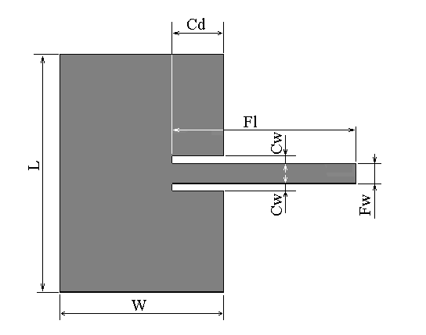
Fig. 1: The text within the figure is Times New Roman, with equivalent height of 10 point, as the caption is. All letters used in the figure are explained in the caption: L = patch length, W = patch width, Cd = cut depth, Cw = cut width, Fl = feed length, Fw = feed width.
3.4.1. Figure captions
Figures must be numbered using Arabic numerals. Figure captions must be in 8 pt Regular font. Captions of a single line (e.g. Figure 2) must be centered whereas multi-line captions must be justified (e.g. Figure 1). Captions with figure numbers must be placed after their associated figures, as shown in Figure 1.
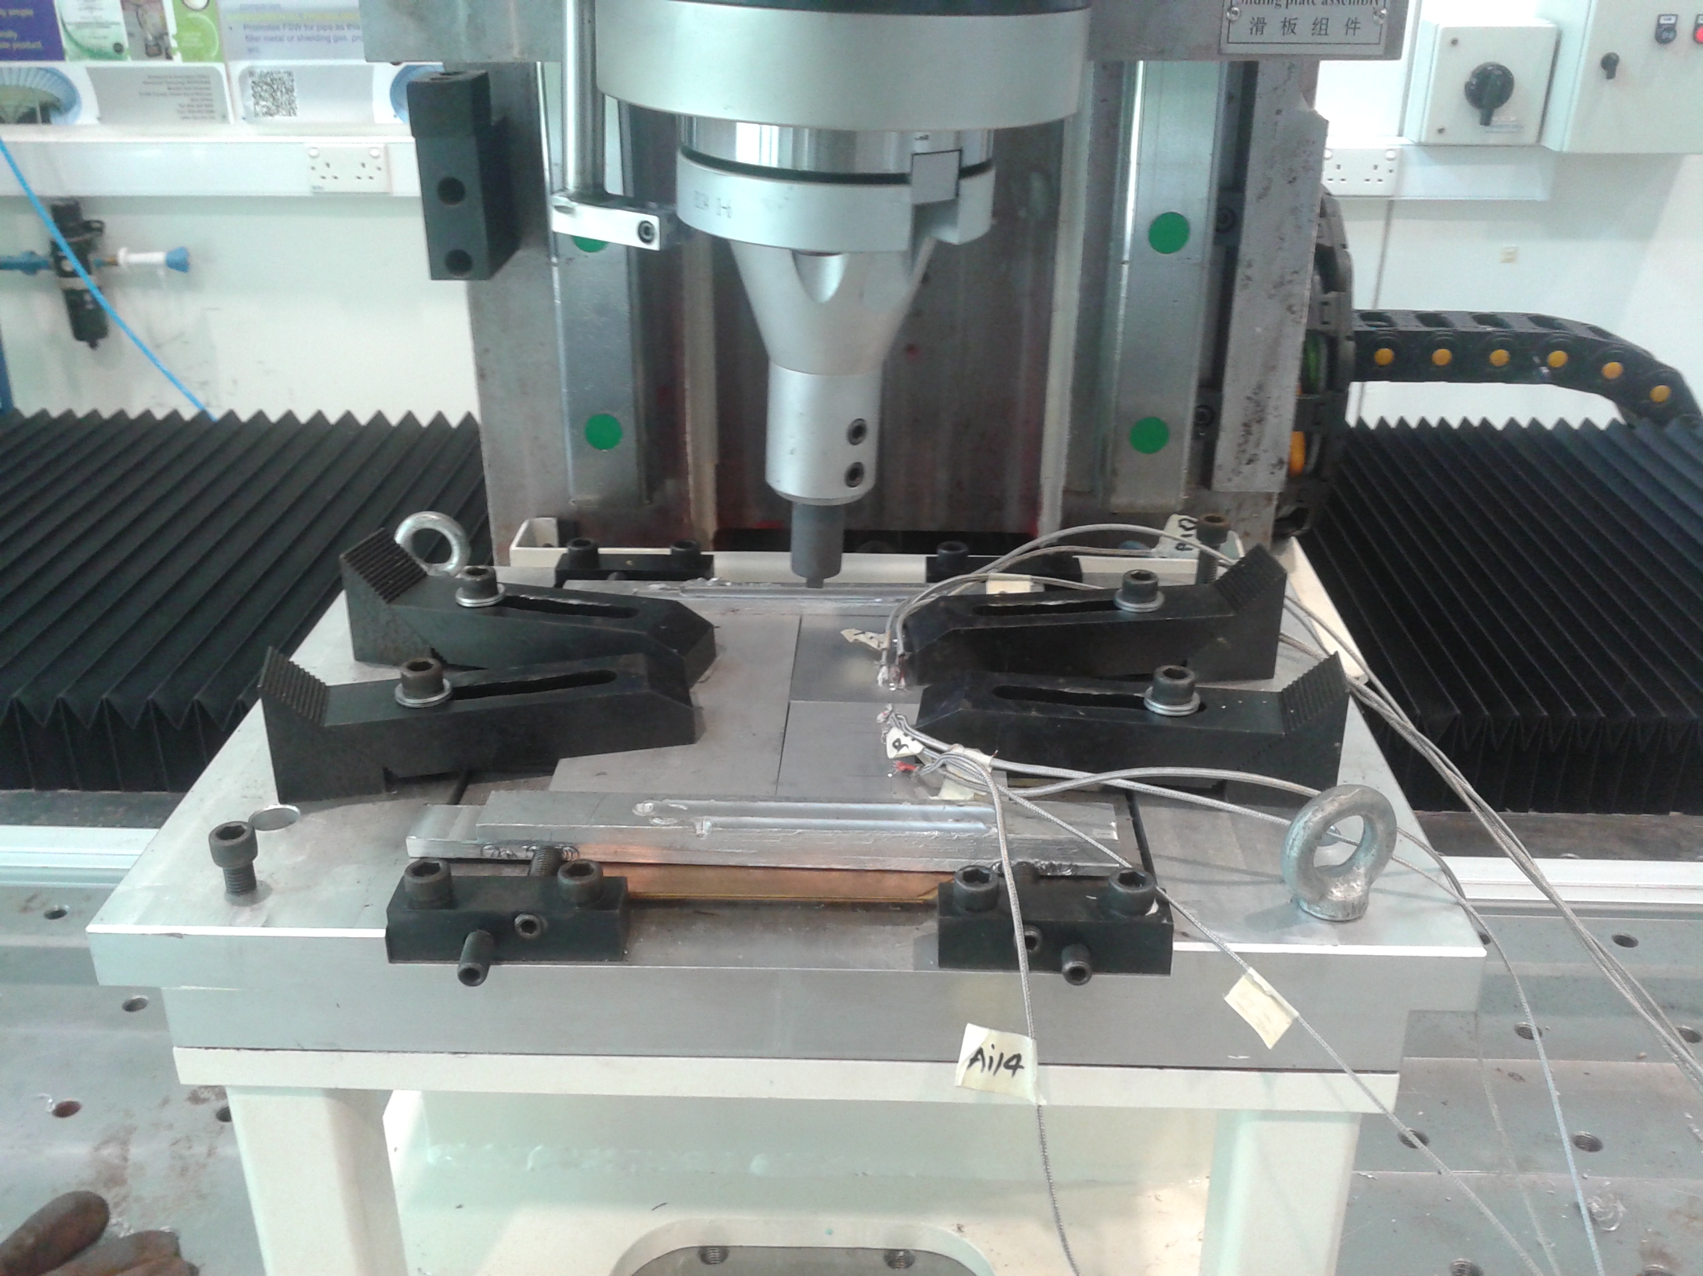

Fig. 2: Example of an image with acceptable resolution
3.4.2. Table captions
Tables must be numbered using Arabic numerals. Table captions must be centred and in 8pt Regular font. Captions with table numbers must be placed before their associated tables, as shown in Table 1.

3.5. Links and bookmarks
All hypertext links and section bookmarks will be removed from papers during the processing of papers for publication. If you need to refer to an Internet email address or URL in your paper, you must type out the address or URL fully in Regular font.

3.6. Equations
Equations should be numbered consecutively throughout the paper. The equation number is enclosed in parentheses and placed flush right, as in (1). Your equation should be typed using the Times New Roman font (please no other font). To create multileveled equations, it may be necessary to treat the equation as a graphic and insert it into the text after your paper is styled.

(1)

Definition 2.1: This is a text of a definition.

(2)

Use the same symbol into a definition over the entire article. Use correct symbols for physical or technical terms. (Example: ε₀ and not ε0 for permittivity). Do not repeat definitions over the article. Refer to already defined symbols, equations, theorems by using the cross reference number (Example: As pointed in (1) the…).
- A step before the final submission
Detailed submission guidelines can be found on the journal web pages. All authors are responsible for understanding these guidelines before submitting their manuscript.
- Conclusion
In this section you should present the conclusion of the paper. Conclusions must focus on the novelty and exceptional results you acquired. Allow a sufficient space in the article for conclusions. Do not repeat the contents of Introduction or the Abstract. Focus on the essential things of your article.
Acknowledgement
This is a text of acknowledgements. Do not forget people who have assisted you on your work. Do not exaggerate with thanks. If your work has been paid by a Grant, mention the Grant name and number here.
References
- Author,”Title of the Paper”, Journal name, Vol.X, No.X, (200X), pp.XX-XX, available online: http://xxx, last visit:28.02.2013
- Author,”Title of the Paper”, Proceedings of the conference name, Vol.X, No.X, (200X), pp:XX-YY, http://dx.doi.org/10.1109/MMM.2013.2248651
- Author, Title of the Book, Publisher, (200X), pp:XXX-YYY.
- Cho JH, Chang SA, Kwon HS, Choi YH, KoSH, Moon SD, Yoo SJ, Song KH, Son HS, Kim HS, Lee WC, Cha BY, Son HY & Yoon KH (2006), Long-term effect of the internet-based glucose monitoring system on HbA1c Reduction and glucose stability: a 30-month follow-up study for diabetes management with a ubiquitous medical care system. Diabetes Care 29, 2625–2631.
- Fauci AS, Braunwald E, Kasper DL & Hauser SL (2008), Principles of Harrison’s Internal Medicine, Vol. 9, 17thedn. McGraw-Hill, New York, NY, pp.2275–2304.
- Kim HS & Jeong HS (2007), A nurse short message service by cellular phone in type-2 diabetic patients for six months. Journal of Clinical Nursing 16, 1082–1087.
- Lee JR, Kim SA, Yoo JW & Kang YK (2007), The present status of diabetes education and the role recognition as a diabetes educator of nurses in korea. Diabetes Research and Clinical Practice 77, 199–204.
- McMahon GT, Gomes HE, Hohne SH, Hu TM, Levine BA & Conlin PR (2005), Web-based care management in patients with poorly controlled diabetes. Diabetes Care 28, 1624–1629.
- Thakurdesai PA, Kole PL & Pareek RP (2004), Evaluation of the quality and contents of diabetes mellitus patient education on Internet. Patient Education and Counseling 53, 309–313.

